CONNOR'S RUN FACEBOOK FUNDRAISING

How do I set up a Facebook Fundraiser?

Facebook fundraising allows for you to collect donations from your Facebook page, to be counted towards your Connor’s Run fundraising total. It is all done through the Facebook platform and supported by the PayPal Giving Fund which grants the donations to the Robert Connor Dawes Foundation.

To create a Facebook fundraiser
- Log into your Connor’s Run dashboard:
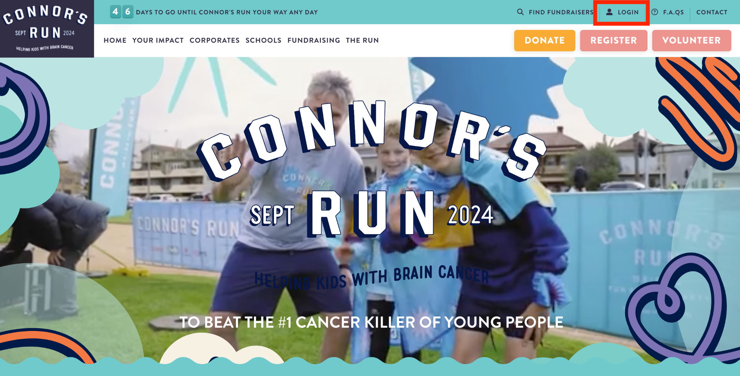

- Next to your profile picture click the ‘Create Facebook Fundraiser’ button.
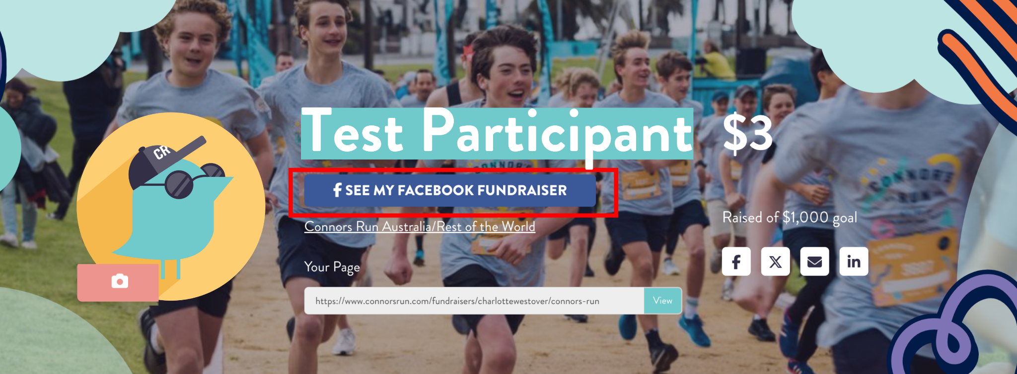
- Follow the prompts to complete your page (make sure you are logged into your personal Facebook).
- Share with your friends on Facebook and remember to give a shout out to your donors and share their donations to encourage further support.
- Once you have created your fundraising page you can locate it by going to https://www.facebook.com/fundraisers/manage under 'Your Active Fundraisers' and your ‘Connor’s ‘Run fundraiser should be at the top.
- If you create a Facebook Fundraiser on Facebook directly (without following the steps from your dashboard), donations received will not appear on your fundraising page. However do not worry if this happens as Connor’s Run/Robert Connor Dawes Foundation will still receive funds raised this way.

- Donations from a Facebook Fundraiser will not show the name of the person making the donation on your Fundraising page – it will only display as “Facebook Donation” however you can still send personalised thank you messages via Facebook to anyone that donates via a Facebook Fundraiser to you and it will still go towards your Fundraising total.
